Part 1
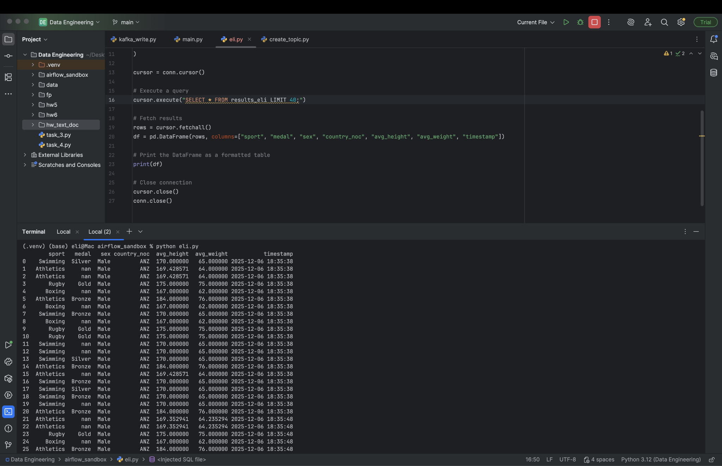
As it can be seen, here is data from the SQL table after all stages of transformations.

Part 2
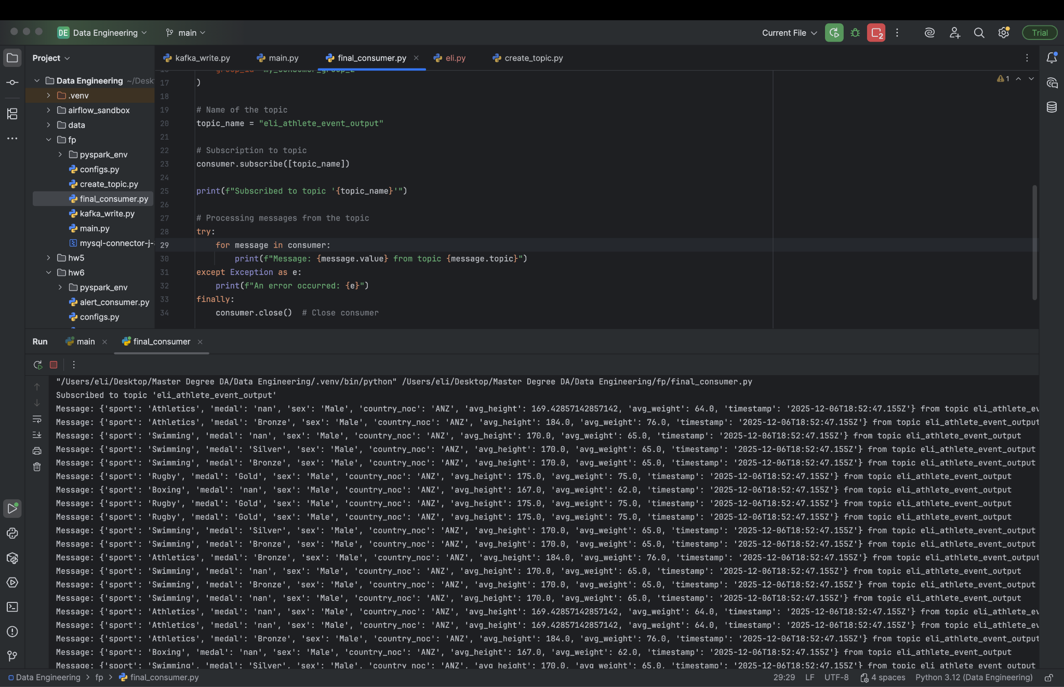

As it can be seen, here is data from the Kafka topic after all stages of transformations.

